INTERMIDIATE TASK

Research Questions on AQI in Delhi
Key Pollutants
1. Which pollutants mainly increase AQI in Delhi?
Answer:
PM2.5 and PM10 are the main pollutants responsible for high AQI in Delhi. Their levels are much higher than safe limits and have the greatest impact on air quality. Other pollutants like NO₂ and CO contribute but to a lesser extent.

2. How are PM2.5 and PM10 related to poor AQI?
Answer:
PM2.5 and PM10 have a strong positive relationship with AQI. When their levels rise, AQI becomes worse, showing that particulate matter is the major cause of air pollution.

Seasonal Variations
3. How does AQI change in different seasons in Delhi?
Answer:
AQI varies by season. It is worst in winter, moderate in summer, and best during the monsoon due to rainfall removing pollutants from the air.

4. Why is AQI very high in winter in Delhi?
Answer:
In winter, low temperatures and weak winds trap pollutants near the ground. Activities like vehicle emissions and biomass burning further increase pollution levels.

Geographical and Environmental Factors
5. How does Delhi’s geography affect air pollution?
Answer:
Delhi is landlocked and surrounded by farming areas. Crop burning, dense buildings, and high population reduce airflow, causing pollutants to accumulate.

6. How do weather conditions affect AQI?
Answer:
Low wind speed and temperature inversion worsen AQI, while rain and strong winds improve air quality by removing pollutants.

7. What do statistics tell us about pollution sources?
Answer:
High average and peak pollution values indicate major sources like traffic, construction, industries, and crop burning, with pollution increasing during specific seasons.

8. How do charts and graphs help understand AQI trends?
Answer:
Graphs clearly show pollution peaks and seasonal patterns, making it easier to identify periods of severe air pollution.

9. How can this analysis help improve air quality?
Answer:
The analysis suggests focusing on reducing particulate pollution, controlling traffic, managing dust, and preventing crop burning, especially in winter.

10. How does poor AQI affect public health?
Answer:
Poor AQI causes breathing problems, heart diseases, and other health issues, especially for children, elderly people, and those with existing illnesses.

Statistical Analysis and Visualization-Based Insights
1. Statistical Analysis
- Descriptive statistics reveal that PM2.5 and PM10 frequently exceed national safety limits, making them the primary drivers of poor AQI.
- Time-series analysis shows recurring pollution spikes, indicating episodic smog events rather than uniform pollution.
- Correlation analysis demonstrates a strong positive relationship between particulate matter and AQI, highlighting their dominant influence.
2. Visualizations
- Line graphs of pollutant concentrations over time illustrate sharp increases during winter periods.
- Monthly average plots show significantly higher AQI and PM levels in winter compared to other seasons.
- Comparative bar charts identify particulate matter as the most critical pollutant category affecting air quality.
3. Types of Data Visualization (Used in AQI Dashboard)
a) Line Chart
Line charts display data points over a continuous period and are ideal for trend analysis over time.
Usage in Dashboard:
- Shows Average PM2.5 by Year, Month, and Day
- Helps identify daily fluctuations and pollution peaks
- Useful for understanding temporal trends

b) Pie Chart
Pie charts represent data as proportions of a whole and are used to show percentage distribution among categories.
Usage in Dashboard:
- Displays Average PM2.5 by AQI Types
- Shows how much time air quality falls into categories like Severe, Very Poor, Poor, Moderate
- Helps assess health risk distribution

c) Bar Chart
Bar charts are used for comparison across multiple categories.
Usage in Dashboard:
- Compares average concentrations of pollutants such as NH₃, NO, O₃, PM10, PM2.5, and SO₂
- Helps identify dominant pollutants affecting air quality

d) Multi-Line Chart (Dual Axis)
Theory:
Multi-line charts compare two or more variables over the same dimension.
Usage in Dashboard:
- Shows Average PM2.5 and PM10 by Hour
- Highlights diurnal variation in pollution levels
- Identifies morning and evening peak pollution hours

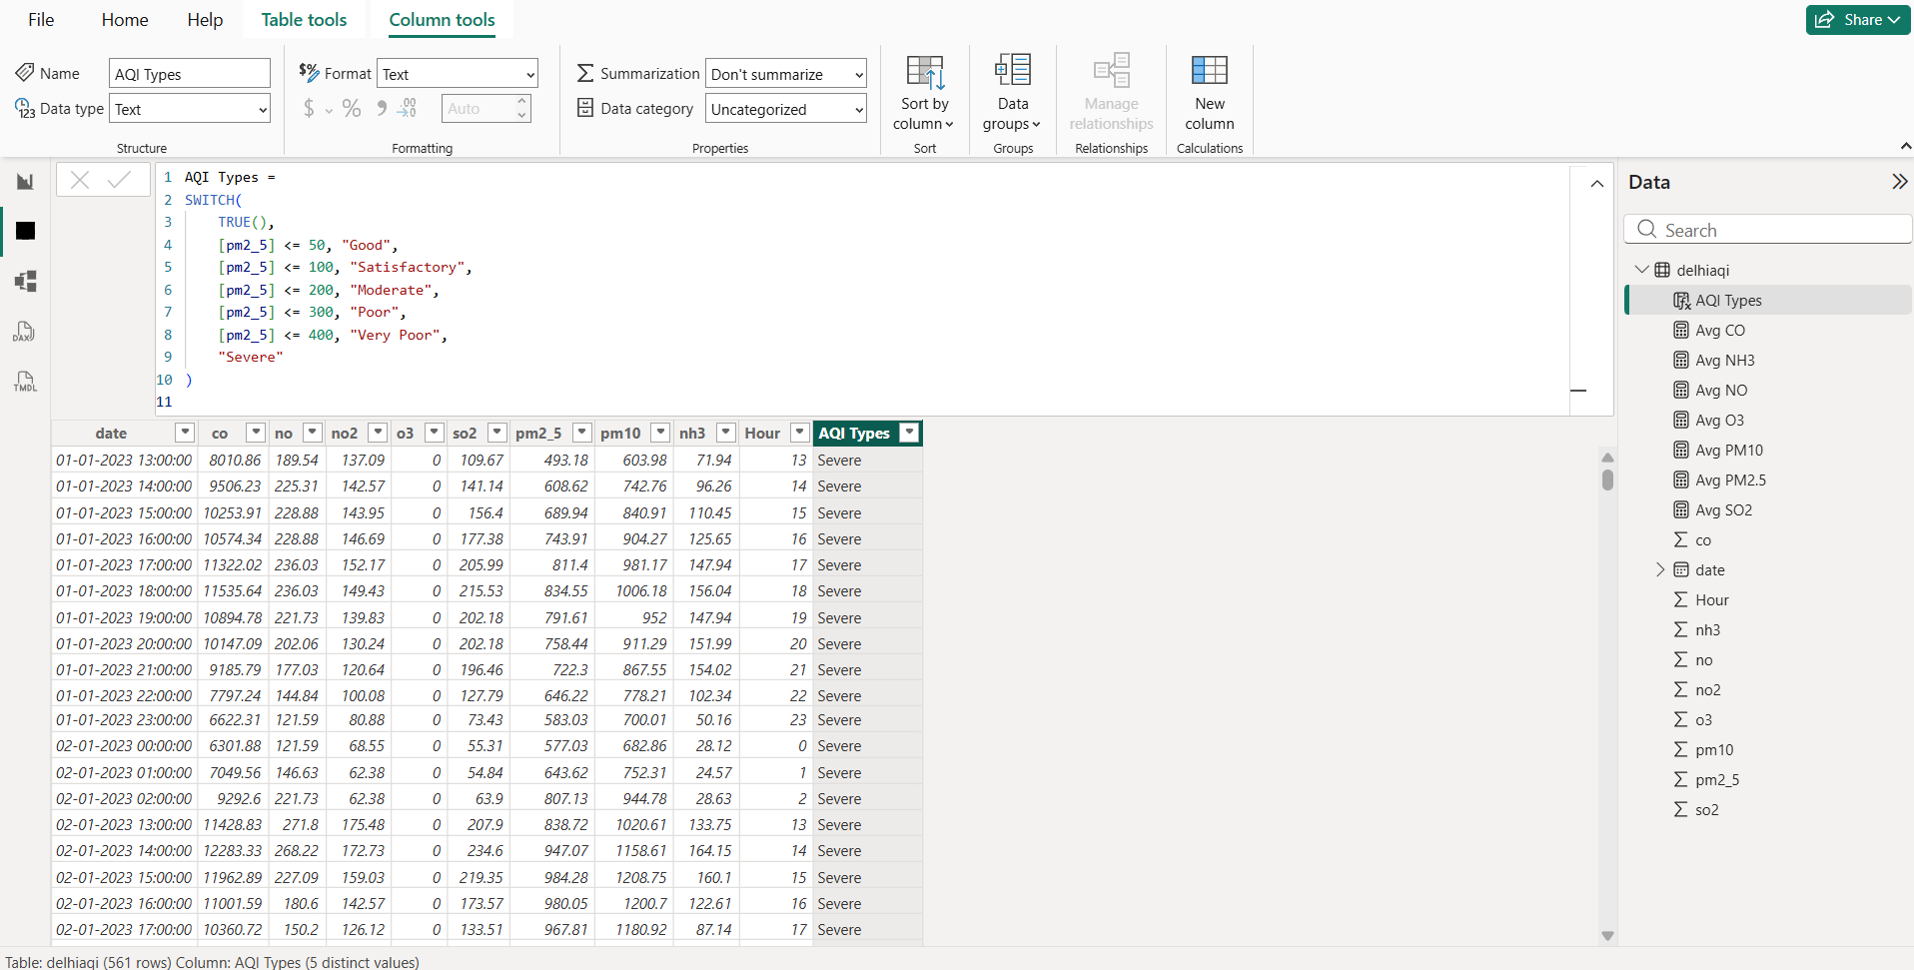

DATA VISUVALIZATION on provided Dataset

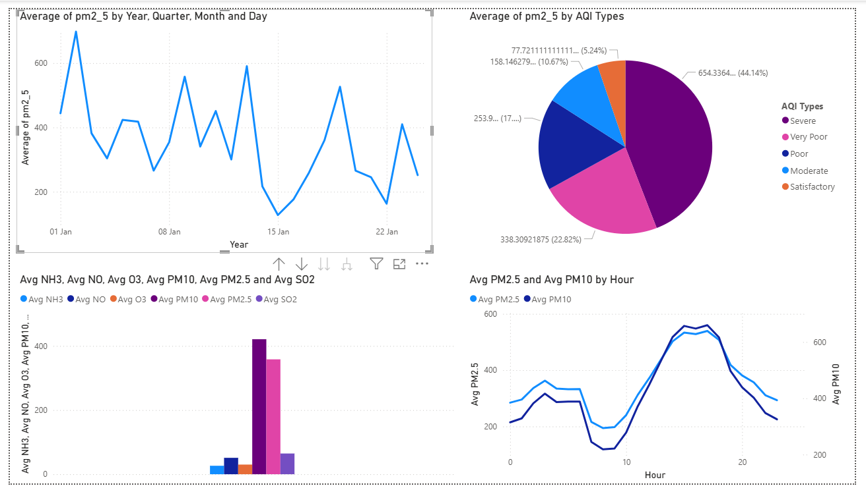

Implications for Air Quality Improvement and Public Health
The analysis confirms that particulate pollution combined with seasonal and geographical constraints is the major cause of severe AQI in Delhi. These insights can guide:
- Targeted emission control policies focusing on traffic, construction dust, and biomass burning.
- Season-specific interventions, such as winter pollution emergency plans.
- Public health advisories for vulnerable populations during high-AQI periods.
- Urban planning strategies to improve ventilation and green cover.

Conclusion
By answering research questions using statistical analysis and visual interpretation, this study provides a comprehensive understanding of AQI dynamics in Delhi. The results emphasize the dominant role of particulate matter, seasonal variability, and geographical constraints, offering valuable insights for effective air quality management and public health protection.

